

Northwind Traders sales analysis report

CAPSTONE PROJECT



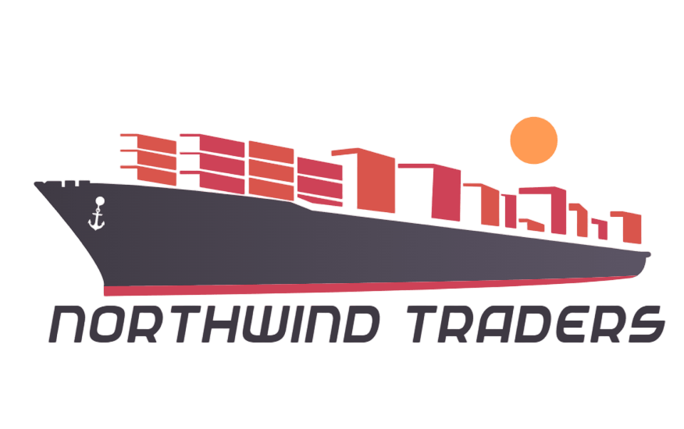

**BY**

**ARYAN UPADHYAY**

# Overview of Power BI Dashboard for Northwind Traders Dataset:

The Power BI Dashboard for the Northwind Traders dataset offers comprehensive insights into various aspects of the business, focusing on customer analysis, order analysis, employee analysis, product analysis, supplier analysis, and shipper analysis. Leveraging data from these different areas, the dashboard provides a holistic view of Northwind Traders' operations, sales performance, and customer interactions.

## Key Components:

### 1. Customer Analysis:

This section of the dashboard highlights customer-related metrics, including customer demographics, purchasing behavior, and sales performance. Visualizations on customer segments, order history, and customer satisfaction ratings help in identifying high-value customers and understanding their preferences.

### 2. Order Analysis:

The Order Analysis section provides an overview of order trends, sales revenue, and order fulfillment metrics. Visualizations on order volumes, revenue by region, and delivery times allow for better inventory management and efficient order processing.

### 3. Employee Analysis:

This section focuses on employee-related data, such as sales performance, employee demographics, and productivity. Visualizations on sales by employee, employee rankings, and performance trends help in recognizing top-performing staff and identifying areas for improvement.

### 4. Product Analysis:

The Product Analysis section showcases insights into product sales, popularity, and profitability. Visualizations on product sales by category, best-selling products, and gross margin percentages assist in optimizing product offerings and pricing strategies.

### 5. Supplier Analysis:

This section provides valuable information on suppliers' performance, delivery reliability, and product quality. Visualizations on supplier ratings, on-time deliveries, and product defect rates enable effective supplier management and selection.

### 6. Shipper Analysis:

The Shipper Analysis section offers insights into shipping efficiency, delivery times, and overall logistics performance. Visualizations on delivery speed, shipping costs, and customer satisfaction with delivery services aid in streamlining shipping operations.

## Benefits:

### 1. Data-Driven Decision Making:

The Power BI Dashboard empowers business stakeholders to make informed decisions based on data-driven insights. This leads to better strategic planning and resource allocation.

### 2. Customer-Centric Approach:

Analyzing customer data allows Northwind Traders to understand customer preferences and behavior, enabling the delivery of personalized services and targeted marketing campaigns.

### 3. Sales Optimization:

Insights from the dashboard aid in optimizing sales strategies, identifying high-performing products, and focusing on profitable customer segments.

### 4. Supply Chain Efficiency:

Analyzing supplier and shipper data facilitates improved supplier management and logistics optimization, resulting in streamlined supply chain operations.

### 5. Employee Performance Enhancement:

Evaluating employee performance data enables recognition of top performers and the implementation of training programs to enhance overall team productivity.

In conclusion, the Power BI Dashboard for the Northwind Traders dataset provides valuable insights into customer analysis, order analysis, employee analysis, product analysis, supplier analysis, and shipper analysis. By leveraging these insights, Northwind Traders can optimize their operations, enhance customer satisfaction, and make data-backed decisions to drive business growth and success

# **Project Objective:**

The primary objective of our project, utilizing the Overview of Power BI Dashboard for the Northwind Traders Dataset, is to empower Northwind Traders with actionable insights derived from comprehensive data analysis. By harnessing the capabilities of the Power BI Dashboard, our project aims to achieve the following objectives:

Enhanced Business Understanding**:** Utilize the Power BI Dashboard's detailed sections on customer analysis, order analysis, employee analysis, product analysis, supplier analysis, and shipper analysis to gain a deep understanding of various facets of the business operations. This understanding forms the foundation for informed decision-making.

Data-Driven Decision Making: Enable Northwind Traders' stakeholders to make strategic decisions backed by data-driven insights. By analyzing customer behavior, order trends, employee performance, product sales, supplier reliability, and shipping efficiency, the project seeks to facilitate precise decision-making processes leading to improved business outcomes.

Operational Optimization**:** Optimize key areas of operations, including inventory management, order processing, sales strategies, supplier management, and shipping logistics. By identifying inefficiencies and bottlenecks through the Power BI Dashboard, our project aims to streamline these processes for increased efficiency and reduced costs.

Customer-Centric Strategies**:** Implement a customer-centric approach by leveraging insights from customer analysis. Understand customer preferences, purchasing behavior, and satisfaction levels to tailor services, marketing initiatives, and product offerings, thereby enhancing customer loyalty and overall satisfaction.

Sales and Revenue Growth**:** Utilize product analysis to identify high-performing products and profitable customer segments. Optimize sales strategies, pricing, and marketing efforts based on these insights, leading to increased sales and revenue generation for Northwind Traders.

Supply Chain and Logistics Optimization**:** Improve supplier relationships and streamline shipping operations by analyzing supplier and shipper data. Enhance supply chain efficiency, reduce costs, and ensure timely deliveries, contributing to a more reliable and cost-effective supply chain network.

Employee Performance Enhancement**:** Evaluate employee performance metrics to recognize top performers and identify areas for improvement. Implement targeted training programs and incentives to enhance overall team productivity and motivation, fostering a positive work environment.

By achieving these objectives, our project endeavors to position Northwind Traders as a data-driven, customer-focused, and operationally efficient organization. The insights derived from the Power BI Dashboard will enable Northwind Traders to make proactive decisions, drive sustainable growth, and ensure long-term success in their industry.

# **Significance of the Project:**

The significance of this project lies in its transformative impact on Northwind Traders' business operations, strategy formulation, and overall competitiveness. Several key aspects highlight the project's significance:

Informed Decision-Making: The project equips Northwind Traders with a robust decision-making framework. By providing detailed insights into customer behavior, sales patterns, employee performance, and supply chain efficiency, the project enables data-driven decision-making. Informed decisions lead to improved operational efficiency, targeted marketing efforts, and strategic resource allocation.

Competitive Advantage: In today's data-driven business landscape, organizations that harness their data effectively gain a competitive edge. By leveraging the Power BI Dashboard, Northwind Traders can stay ahead of competitors. Understanding customer preferences, optimizing sales strategies, and enhancing supply chain operations contribute to a competitive advantage in the market.

Customer Satisfaction and Retention: Through customer analysis, Northwind Traders can deliver personalized services, respond to customer needs effectively, and create tailored marketing campaigns. Satisfied customers are more likely to remain loyal and make repeat purchases, fostering long-term relationships and brand loyalty.

Operational Efficiency: The project targets operational inefficiencies by optimizing inventory management, order processing, and supply chain logistics. Streamlined operations not only reduce costs but also improve the overall efficiency of the business, ensuring timely deliveries and customer satisfaction.

Revenue Growth: By identifying high-performing products and profitable customer segments, the project aids in optimizing sales strategies. Focusing marketing efforts on the right products and customer groups increases sales opportunities, leading to revenue growth and improved financial performance.

Supply Chain Resilience: A streamlined supply chain, facilitated by effective supplier and shipper analysis, enhances supply chain resilience. Timely deliveries, reduced defects, and efficient logistics contribute to a robust and adaptable supply chain, capable of responding to market demands and disruptions effectively.

Employee Engagement and Productivity: Employee analysis fosters a positive work environment by recognizing and rewarding top performers. Targeted training programs enhance employee skills and productivity, leading to a motivated workforce. Engaged employees contribute to improved customer service and overall business success.

Strategic Planning: The insights derived from the Power BI Dashboard serve as a foundation for strategic planning. Northwind Traders can align their business strategies with market demands and customer preferences, ensuring the company's growth trajectory is aligned with industry trends and customer expectations.

In summary, the significance of this project lies in its ability to empower Northwind Traders with the tools and insights necessary to thrive in a competitive market. By enhancing decision-making processes, optimizing operations, and focusing on customer satisfaction, the project positions Northwind Traders for sustained growth, profitability, and long-term success.

|  |  |  |  |
| --- | --- | --- | --- |
|  | Data Dictionary | |  |
|  |  |  |  |
| Table Name: Category |  |  |  |
|  |  |  |  |
|  |  |  |  |
| **Column Name** | **Data Type** | **Constraints** | **Description** |
| CategoryID | int | Primary Key, Auto Increment | Unique identifier for each category. |
| CategoryName | varchar(15) |  | Name of the category. Limited to 15 characters. |
| Description | longtext |  | Description or details about the category. |
|  |  |  |  |
| Table Name: Customers |  |  |  |
|  |  |  |  |
|  |  |  |  |
| **Column Name** | **Data Type** | **Constraints** | **Description** |
| CustomerID | varchar(5) | Primary Key | Unique identifier for each customer. Limited to 5 characters. |
| CompanyName | varchar(40) |  | Name of the customer's company. Limited to 40 characters. |
| ContactName | varchar(30) |  | Name of the primary contact person at the company. Limited to 30 characters. |
| ContactTitle | varchar(30) |  | Title or position of the primary contact person. Limited to 30 characters. |
| Address | varchar(60) |  | Street address of the customer. Limited to 60 characters. |
| City | varchar(15) |  | City where the customer is located. Limited to 15 characters. |
| Region | varchar(15) |  | Region or state where the customer is located. Limited to 15 characters. |
| PostalCode | varchar(10) |  | Postal code of the customer's location. Limited to 10 characters. |
| Country | varchar(15) |  | Country where the customer is located. Limited to 15 characters. |
| Phone | varchar(24) |  | Phone number for contacting the customer. Limited to 24 characters. |
| Fax | varchar(24) |  | Fax number for contacting the customer. Limited to 24 characters. |
|  |  |  |  |
|  |  |  |  |
|  |  |  |  |
|  |  |  |  |
| Table Name: Employees |  |  |  |
|  |  |  |  |
|  |  |  |  |
|  |  |  |  |
| **Column Name** | **Data Type** | **Constraints** | **Description** |
| EmployeeID | int | Primary Key, Auto Increment | Unique identifier for each employee. |
| LastName | varchar(20) |  | Last name of the employee. Limited to 20 characters. |
| FirstName | varchar(10) |  | First name of the employee. Limited to 10 characters. |
| Title | varchar(30) |  | Job title or position of the employee. Limited to 30 characters. |
| TitleOfCourtesy | varchar(25) |  | Honorific title used with the employee's name. Limited to 25 characters. |
| BirthDate | datetime |  | Date of birth of the employee. |
| HireDate | datetime |  | Date when the employee was hired. |
| Address | varchar(60) |  | Street address of the employee. Limited to 60 characters. |
| City | varchar(15) |  | City where the employee is located. Limited to 15 characters. |
| Region | varchar(15) |  | Region or state where the employee is located. Limited to 15 characters. |
| PostalCode | varchar(10) |  | Postal code of the employee's location. Limited to 10 characters. |
| Country | varchar(15) |  | Country where the employee is located. Limited to 15 characters. |
| HomePhone | varchar(24) |  | Home phone number of the employee. Limited to 24 characters. |
| Extension | varchar(4) |  | Phone extension number for the employee. Limited to 4 characters. |
| Photo | longblob |  | Binary data for the employee's photo. |
| Notes | longtext |  | Additional notes or comments about the employee. |
| ReportsTo | int |  | EmployeeID of the person to whom this employee reports. |
|  |  |  |  |
| Table Name: OrderDetails |  |  |  |
|  |  |  |  |
|  |  |  |  |
| **Column Name** | **Data Type** | **Constraints** | **Description** |
| OrderID | int | Primary Key | Unique identifier for each order. |
| ProductID | int | Primary Key | Unique identifier for each product in the order. |
| UnitPrice | decimal(19,4) |  | Price of a single unit of the product. |
| Quantity | int |  | Number of units of the product ordered. |
| Discount | float |  | Discount applied to the product (in percentage). |
|  |  |  |  |
| Table Name: Orders |  |  |  |
|  |  |  |  |
|  |  |  |  |
| **Column Name** | **Data Type** | **Constraints** | **Description** |
| OrderID | int | Primary Key, Auto Increment | Unique identifier for each order. |
| CustomerID | varchar(5) |  | Identifier for the customer placing the order. Limited to 5 characters. |
| EmployeeID | int |  | Identifier for the employee processing the order. |
| OrderDate | datetime |  | Date and time when the order was placed. |
| RequiredDate | datetime |  | Date by which the order needs to be fulfilled. |
| ShippedDate | datetime |  | Date and time when the order was shipped. |
| ShipVia | int |  | Shipping method identifier. |
| Freight | decimal(19,4) |  | Cost of shipping the order. |
| ShipName | varchar(40) |  | Name of the recipient/receiving company. Limited to 40 characters. |
| ShipAddress | varchar(60) |  | Street address for shipping. Limited to 60 characters. |
| ShipCity | varchar(15) |  | City for shipping address. Limited to 15 characters. |
| ShipRegion | varchar(15) |  | Region or state for shipping address. Limited to 15 characters. |
| ShipPostalCode | varchar(10) |  | Postal code for shipping address. Limited to 10 characters. |
| ShipCountry | varchar(15) |  | Country for shipping address. Limited to 15 characters. |
|  |  |  |  |
|  |  |  |  |
| Table Name: products |  |  |  |
|  |  |  |  |
|  |  |  |  |
| **Column Name** | **Data Type** | **Constraints** | **Description** |
| ProductID | int | Primary Key, Auto Increment | Unique identifier for each product. |
| ProductName | varchar(40) |  | Name of the product. Limited to 40 characters. |
| SupplierID | int |  | Identifier for the supplier of the product. |
| CategoryID | int |  | Identifier for the category of the product. |
| QuantityPerUnit | varchar(20) |  | Description of quantity per unit (e.g., 10 boxes). Limited to 20 characters. |
| UnitPrice | decimal(19,4) |  | Price of a single unit of the product. |
| UnitsInStock | int |  | Number of units currently available in stock. |
| UnitsOnOrder | int |  | Number of units currently on order. |
| ReorderLevel | int |  | Minimum level of units before reordering. |
| Discontinued | tinyint(1) |  | Flag indicating if the product is discontinued (1 for discontinued, 0 for active). |
|  |  |  |  |
|  |  |  |  |

|  |  |  |  |
| --- | --- | --- | --- |
| Table Name: shippers |  |  |  |
|  |  |  |  |
|  |  |  |  |
|  |  |  |  |
| **Column Name** | **Data Type** | **Constraints** | **Description** |
| ShipperID | int | Primary Key, Auto Increment | Unique identifier for each shipper. |
| CompanyName | varchar(40) |  | Name of the shipping company. Limited to 40 characters. |
| Phone | varchar(24) |  | Phone number for contacting the shipper. Limited to 24 characters. |
|  |  |  |  |
|  |  |  |  |
| Table name :Suppliers |  |  |  |
|  |  |  |  |
| **Column Name** | **Data Type** | **Constraints** | **Description** |
| SupplierID | int | Primary Key, Auto Increment | Unique identifier for each supplier. |
| CompanyName | varchar(40) |  | Name of the supplier's company. Limited to 40 characters. |
| ContactName | varchar(30) |  | Name of the primary contact person at the company. Limited to 30 characters. |
| ContactTitle | varchar(30) |  | Title or position of the primary contact person. Limited to 30 characters. |
| Address | varchar(60) |  | Street address of the supplier. Limited to 60 characters. |
| City | varchar(15) |  | City where the supplier is located. Limited to 15 characters. |
| Region | varchar(15) |  | Region or state where the supplier is located. Limited to 15 characters. |
| PostalCode | varchar(10) |  | Postal code of the supplier's location. Limited to 10 characters. |
| Country | varchar(15) |  | Country where the supplier is located. Limited to 15 characters. |
| Phone | varchar(24) |  | Phone number for contacting the supplier. Limited to 24 characters. |
| Fax | varchar(24) |  | Fax number for contacting the supplier. Limited to 24 characters. |
| HomePage | longtext |  | Website or homepage of the supplier. Can store large text data. |

# **E-r diagram**

The Entity-Relationship (ER) diagram for the sample Northwind Traders database visually represents the relationships and interactions between various entities (tables) in the database. Here's an explanation of the ER diagram based on the provided tables:

Customers: Represents individual customers of Northwind Traders. Each customer is identified by a unique customer ID and contains attributes such as customer name, contact information, and address.

Employees: Represents the employees working for Northwind Traders. Each employee is identified by a unique employee ID and contains attributes like employee name, job title, and contact details.

Products: Stores information about the products offered by Northwind Traders. Each product is identified by a unique product ID and contains attributes such as product name, unit price, and quantity in stock.

Orders: Represents customer orders placed with Northwind Traders. Each order is identified by a unique order ID and contains attributes like order date, customer ID (foreign key), and employee ID (foreign key) responsible for processing the order.

Suppliers: Represents the suppliers from whom Northwind Traders purchases products. Each supplier is identified by a unique supplier ID and contains attributes like company name, contact information, and address.

Categories: Stores different product categories to which products belong. Each category is identified by a unique category ID and contains attributes like category name and description.

Shippers: Represents shipping companies responsible for delivering orders. Each shipper is identified by a unique shipper ID and contains attributes like company name and contact information.

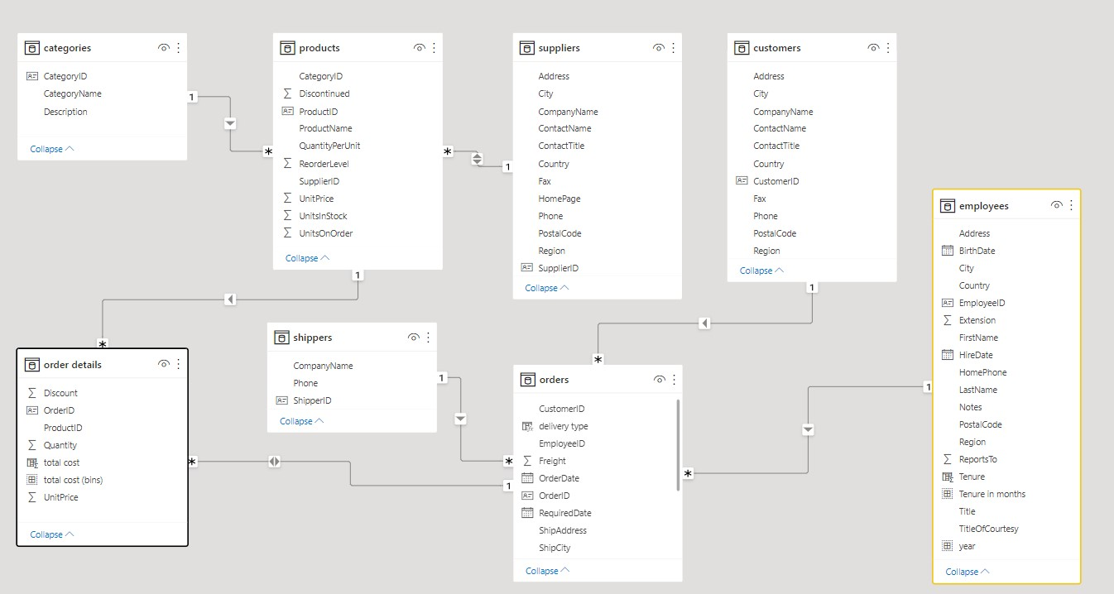

# THE PROCESS

## Data Acquisition from GitHub:

Retrieve the necessary dataset from the Northwind database, containing essential information about customers, orders, employees, products, suppliers, and shippers. Ensure comprehensive coverage of relevant data points.

## DATA TRANSFORMATION AND ENHANCEMENT:

Create a detailed project report outlining the project lifecycle. Include sections on data collection methods, transformation techniques, problem statement formulation, tools integration, Power BI solutions, Exploratory Data Analysis (EDA) insights, and PowerPoint visualizations. Document the entire process meticulously.

## DATA CONNECTION AND PREPARATION:

Establish connections between the Northwind database and analytical tools such as Power BI, Excel, and SQL Server Management Studio. Prepare the dataset for analysis, ensuring data integrity and consistency.

## PROBLEM STATEMENT SOLUTIONS IN POWER BI:

Utilize Power BI's advanced features to address specific problem statements related to customer analysis, order trends, employee performance, product sales, supplier management, and shipping efficiency. Employ data visualization, exploration, and analysis tools in Power BI to derive actionable insights and formulate solutions.

## EXPLORATORY DATA ANALYSIS (EDA) USING EXCEL AND MYSQL workbench:

Conduct Exploratory Data Analysis (EDA) using Excel and MYSQL workbench, based on the complexity of the analysis. Extract meaningful patterns, relationships, and trends from the data. Use statistical methods and visualizations to gain insights into different aspects of the business.

## CREATION OF VISUAL AND INSIGHTFUL POWERPOINT PRESENTATION:

Develop a comprehensive PowerPoint presentation summarizing the project's objectives, methodologies, problem statement solutions, and key visualizations. Dedicate sections to each problem statement, providing in-depth analysis, conclusions, and actionable insights. Use visuals and charts to enhance the presentation's impact.

## DETAILED DOCUMENTATION:

Compile a detailed project report documenting each stage of the project. Include thorough explanations of data acquisition, transformation processes, tools integration, Power BI solutions, EDA findings, and PowerPoint visualizations. Provide insights into decision-making processes and the impact of the analysis on Northwind Traders' operations. Ensure clarity and coherence in the documentation for future reference and analysis.

# EDA in power BI

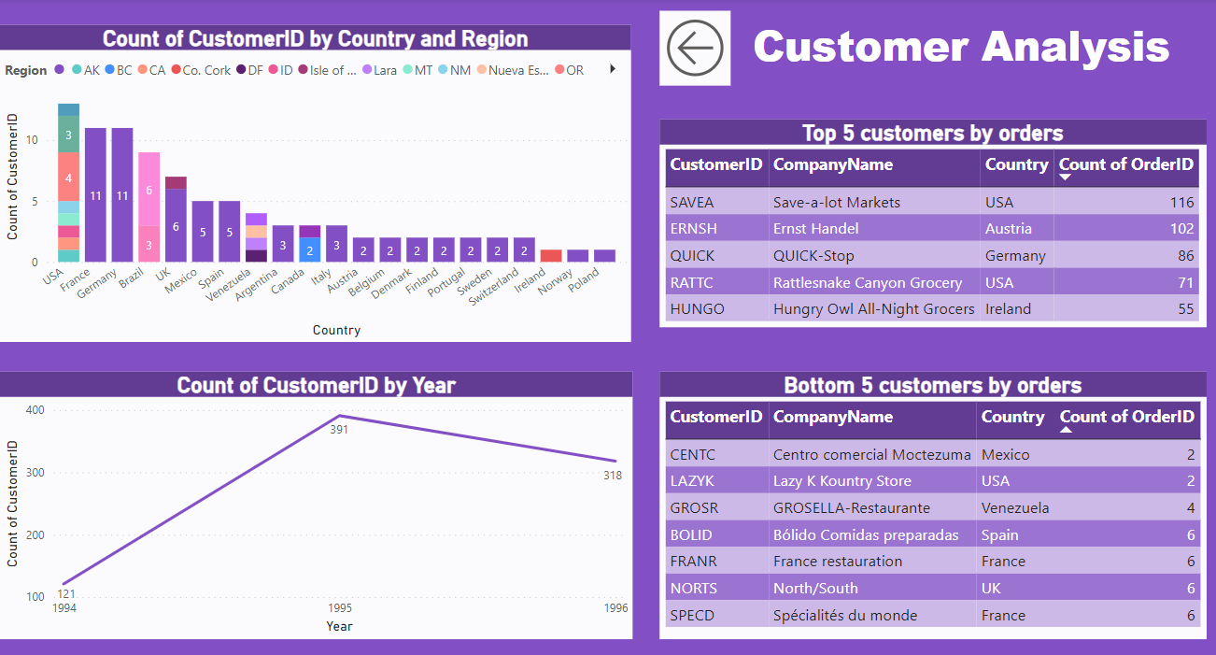

## How does customer distribution vary across different regions or customer segments?

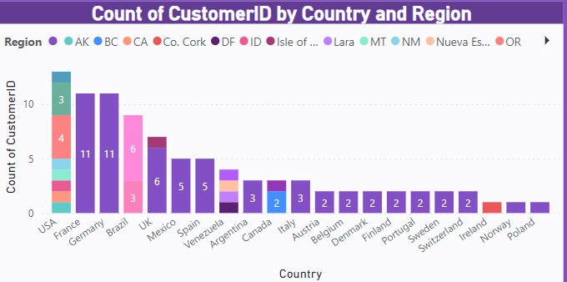

##### IN our data set we don’t have data for regions for all the customers most of the data is vacant. alternatively we have use data of customers country . IN our bar graph we can see the customer distribution from different countries and we have shown regions in that country for which data was given to us . we can clearly see USA has the highest number of customers.

## What is the trend in customer acquisition over time? Can we create a line chart or area chart to display it?

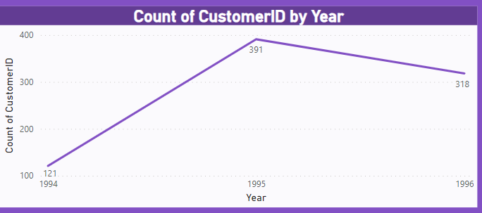

##### We have Line graph for the customer acquisition over the years. Here we can see that in first year we have increased number of customers. But after that we have started declining in the next year.

## Can we visualize the distribution of customer demographics such as age, gender, or income using histograms or pie charts?

##### **Yes, you can visualize the distribution of customer demographics such as age, gender, or income using histograms or pie charts in Power BI BUt we don’t have data for customer dempgraphics(like dob, age or gender).** Here's how you can create these visualizations:

##### **1. Histogram for Age Distribution:**

##### In Power BI Desktop, go to the "Visualizations" pane.

##### Select the "Histogram" chart type.

##### Drag the "Age" field from your dataset into the "Values" field well of the histogram.

##### Power BI will automatically group ages into bins and create a histogram.

##### **2. Pie Chart for Gender Distribution:**

##### Choose the "Pie Chart" visualization from the "Visualizations" pane.

##### Drag the "Gender" field into the "Values" field well of the pie chart.

##### Power BI will create a pie chart showing the distribution of customers by gender.

##### **3. Histogram or Bar Chart for Income Distribution:**

##### For income distribution, you can use either a histogram or a bar chart.

##### For a histogram, follow similar steps as the age distribution but use the "Income" field instead.

##### For a bar chart, select the "Clustered bar chart" from the "Visualizations" pane and place "Income" on the axis and any other relevant field (such as customer count) in the "Values" field well.

Top of Form

## List down the top 5 customers and bottom 5 customers by orders

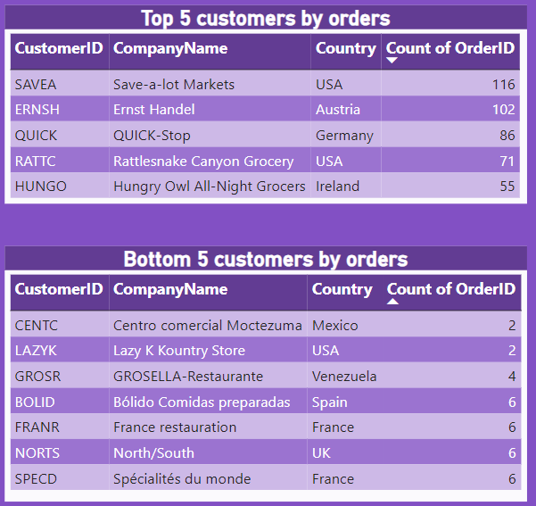

##### Here we have list of Top 5 and bottom 5 customers by sales. We can clearly see customer id “SAVEA” is our biggest customer in terms of orders with 116 orders and customer id “CENTC” and “LAZYK” are the customers which have given only 2 orders .

## How does order volume change over time? Can we create a time series chart or stacked bar chart to visualize it?

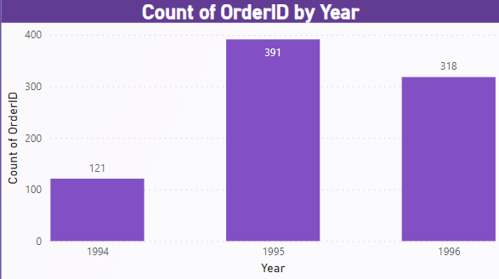

##### Here we have the bar graph showing number of orders placed in each year. We can clearly see that in year 1995 we have the highest number of order which were 391 and we have lowest number of order in 1994 with 121 number of orders. But over the years we can see for the first year we have increased number of orders but in year 1996 we have decreased number of orders which is showing decline in sales.

## What is the distribution of order values? Can we create a histogram or box plot to display it?

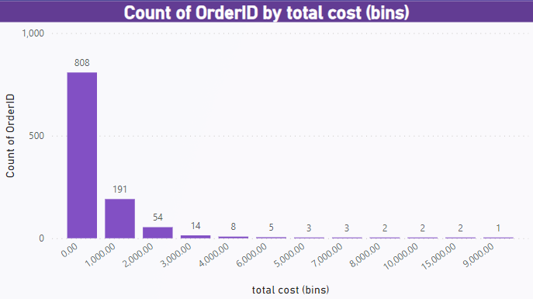

##### Here we have a histogram of orders by their total cost, we have created a price bin of 1000 which we can se in histogram. AS we can interpret from the histogram we have maximum number of orders which cost less than 1000.

## Can we visualize the average order processing time or shipping duration using a bar chart or box plot?

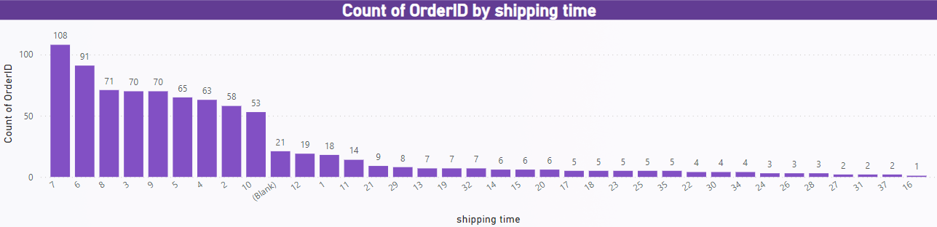

##### Here we have the bar graph for count of orders by their shipping time. We can interpret from the bar graph At 108, 7 had the highest Count of Orders and was 10,700.00% higher than 16, which had the lowest Count of Orders at 1.﻿

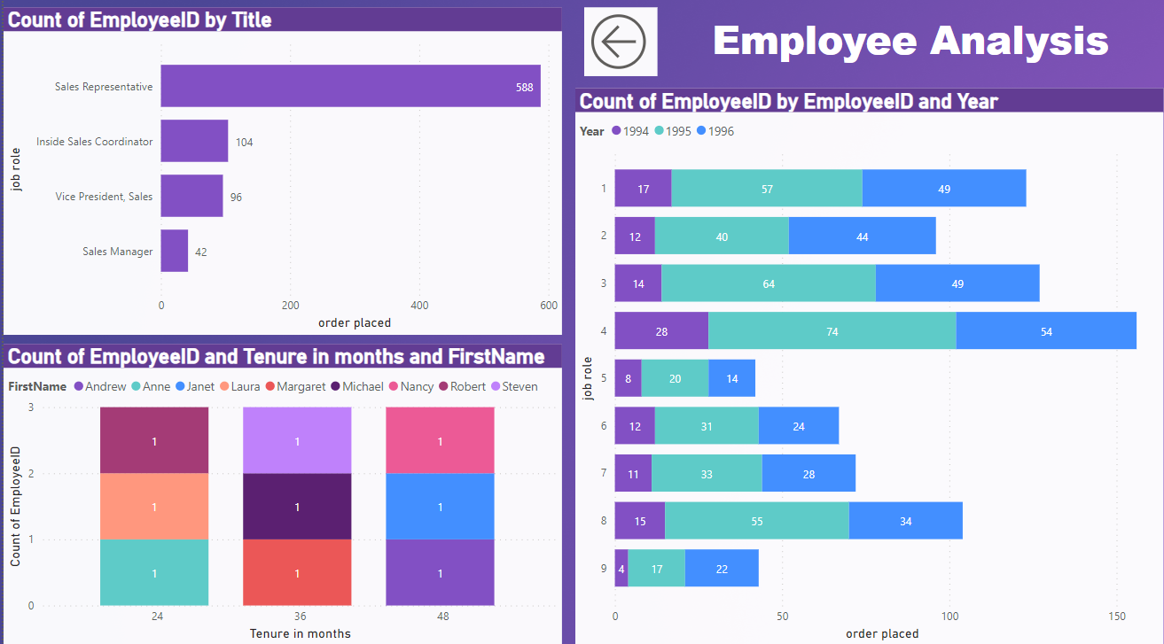

## How does employee productivity vary across different departments or job roles? Can we create a stacked bar chart or grouped column chart to visualize it?

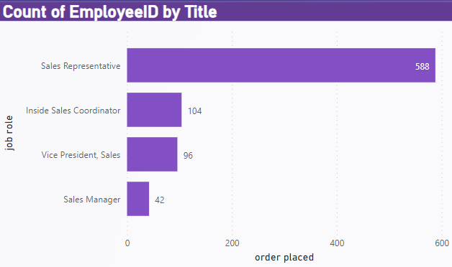

##### Here we have bar chart for job roles and sales done by them. At 588, Sales Representative had the highest Count of orders and was 1,300.00% higher than Sales Manager, which had the lowest Count of orders at 42.

## What is the distribution of employee tenure? Can we create a histogram or box plot to display it?

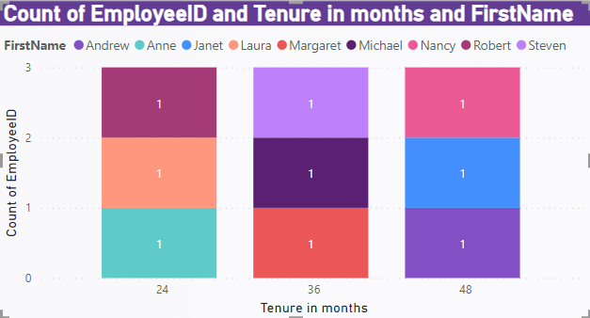

##### Here we have the tenure till 31st of December 1996 because we have data till 1996. We can clearly see we have 3 employees in each bin of 24 months, 36 months and 48 months.

## Can we visualize employee performance ratings or KPIs using a radar chart or bullet graph?

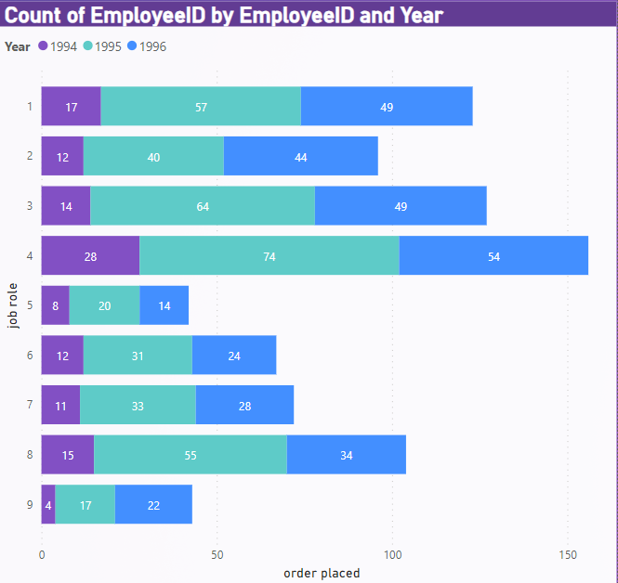

##### We don’t have a rating for employee performance instead we have shown yearly sales done by each employee. At 156, 4 had the highest Count of orders and was 271.43% higher than 5, which had the lowest Count of orders at 42.

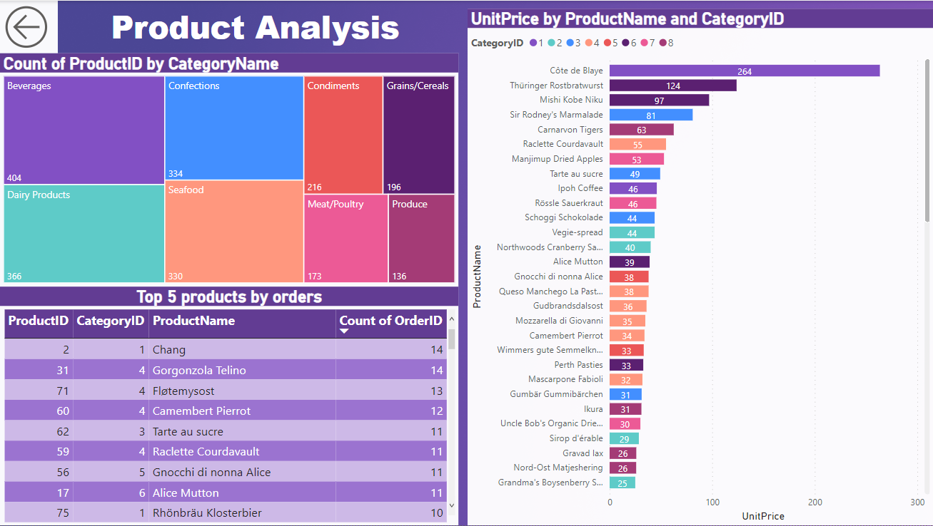

## What is the distribution of product ratings or reviews? Can we create a histogram or stacked bar chart to visualize it?

Yes, you can visualize the distribution of product ratings or reviews using a histogram or a stacked bar chart in Power BI But we don’t have data of product rating or reviews by customers so we can’t create it . Here's how you can create these visualizations:

##### 1. Histogram for Product Ratings Distribution:

##### In Power BI Desktop, go to the "Visualizations" pane.

##### Select the "Histogram" chart type.

##### Drag the "Product Ratings" or "Reviews" field from your dataset into the "Values" field well of the histogram.

##### Power BI will automatically group ratings or reviews into bins and create a histogram, showing the distribution of product ratings.

##### 2. Stacked Bar Chart for Product Ratings Distribution:

##### Choose the "Stacked bar chart" visualization from the "Visualizations" pane.

##### Drag the "Product Ratings" or "Reviews" field into the "Values" field well of the stacked bar chart.

##### Drag another categorical field (such as "Product Categories" or "Product Names") into the "Axis" field well to break down ratings by categories.

##### Power BI will create a stacked bar chart where each bar represents a category (e.g., product category or name) and is divided into segments representing different ratings.

## How does the sales volume vary across different product categories? Can we create a bar chart or treemap to display it?

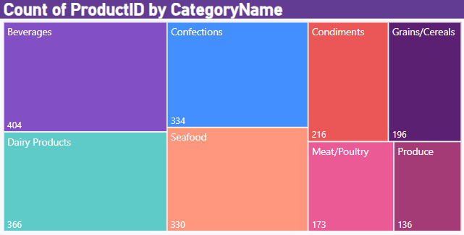

##### Here we have the treemap for product categories with their sales. We can clearly see beverages has the highest number of orders 404. Where produce has the lowest number of sales orders with 136 orders.

## Can we visualize the pricing distribution of products using a bar graph?

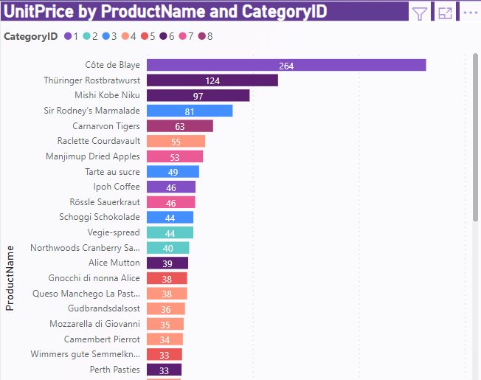

##### Here we have bar graph for product and their unit price. At 263.50, Côte de Blaye had the highest UnitPrice and was 10,440.00% higher than Geitost, which had the lowest UnitPrice at 2.50

## List down top 5 products by the number of orders

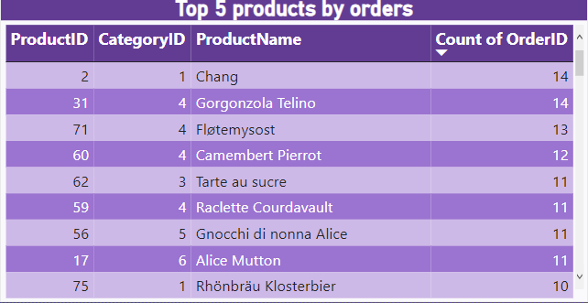

##### Here we have list of Top 5 selling products by number of orders. We can see product id 2 and 31 has the highest selling product will maximum number of orders 14.

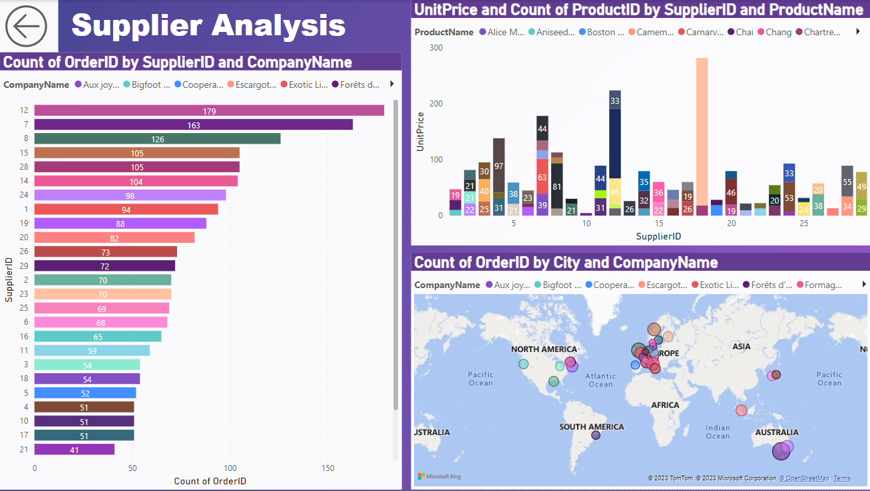

## What is the distribution of supplier ratings or performance metrics? Can we create a bar chart or radar chart to visualize it?

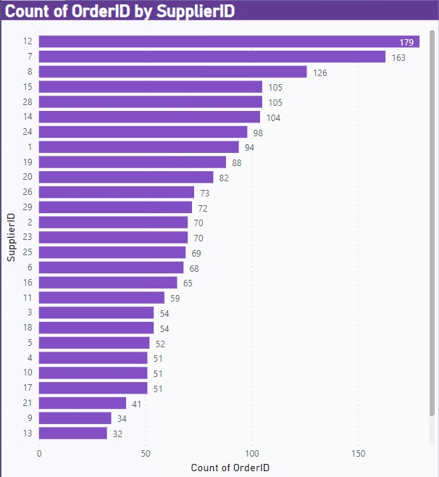

##### Here we have shown number of orders supplied by suppliers to customers. We don’t have data for rating we have made this graph. At 179, Supplier Id 12 had the highest Count of Orders and was 894.44% higher than Supplier Id 27, which had the lowest Count of Orders at 18.

## How does the cost or pricing structure vary across different suppliers? Can we create a box plot or stacked bar chart to display it?

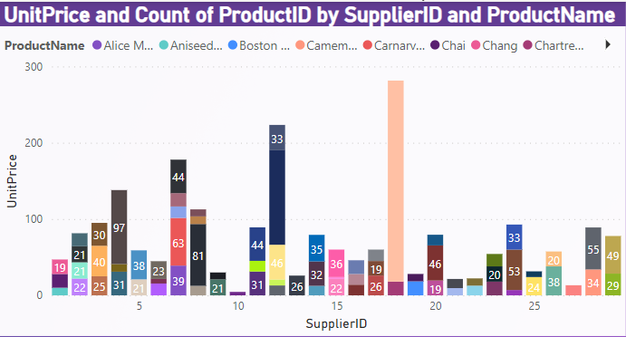

##### Here we have bar graph for pricing structure for different supplier. We can see every supplier has different product with different unit price for it.18 in ProductName made up 11.85% of UnitPrice.

## Can we visualize the geographical distribution of suppliers using a map or bubble chart?

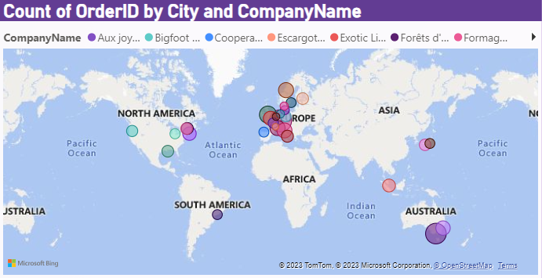

##### Here we have map for different supplier companies from different location.Frankfurt in Company Name made up 8.31% of Count of Orders.

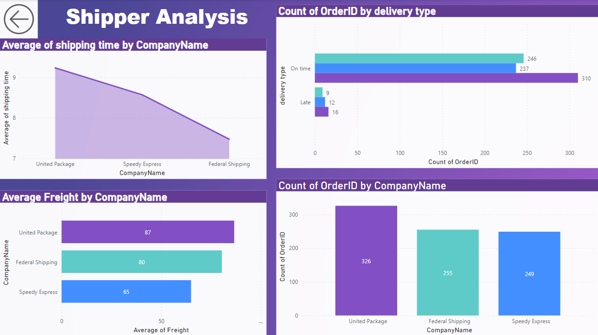

## Average time taken by each company for shipping

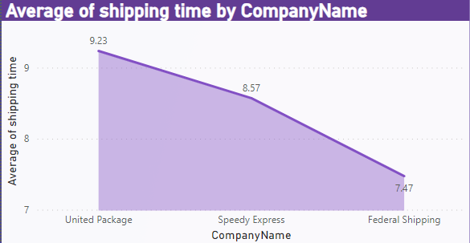

##### Here we can see that united Packages takes highest time to deliver orders and Federal shipping takes minimum time for shipping.

## countof on time and late delivery by shippers

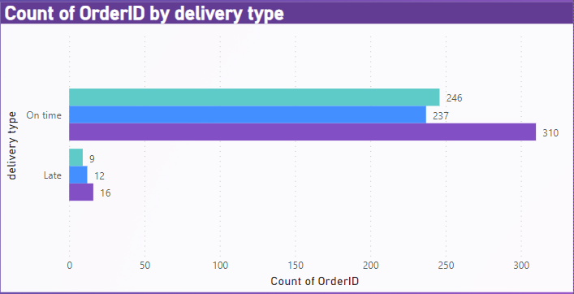

##### United Package had the highest on time delivery with total Count of Orders 310, followed by Federal Shipping at 246 and Speedy Express at 237. While Federal has minimum number of late orders.

## Average freight taken by each supplier company

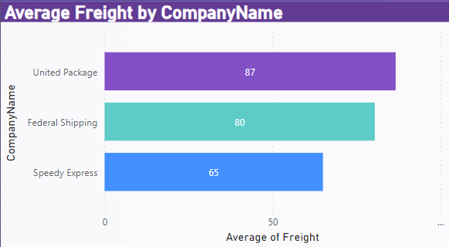

##### Here we have a bar graph showing average freight taken by each shipping company. At 86.64, United Package had the highest Average of Freight and was 33.29% higher than Speedy Express, which had the lowest Average of Freight at 65.00.

## NUmber of orders shipped by each company

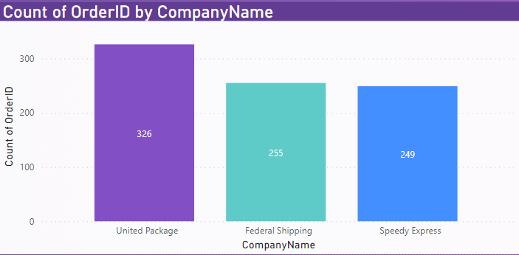

##### Here we have bar graph showing number of orders shipped by each company. United Package had the highest Count of Orders at 326, followed by Federal Shipping at 255 and Speedy Express at 249

# Eda using Mysql and excel

## What are the key factors influencing customer retention or loyalty based on the dataset?

##### Given the limited data availability, analysing the key factors affecting customer retention for Northwind Traders might require a combination of data-driven analysis and qualitative insights. Here are some steps that can help in exploring and understanding customer retention factors:

##### Customer Feedback and Surveys: Conduct customer surveys or collect feedback through various touchpoints to gather qualitative data on customer satisfaction, experience, and preferences. Utilize open-ended questions to understand their perceptions of product or service quality, customer service satisfaction, and overall experience.

##### Qualitative Analysis: Perform qualitative analysis on the gathered feedback to identify recurring themes, pain points, and positive aspects that contribute to customer loyalty. Look for patterns related to convenience, personalization, communication, and brand reputation.

##### Customer Interaction Analysis: Review customer interactions, such as support tickets, inquiries, and complaints, to understand how the company addresses customer issues and concerns. Identify areas for improvement in customer engagement, communication, and problem resolution.

##### Sales and Order Data Analysis: Analyse historical sales and order data to identify patterns related to customer behaviour, purchase frequency, and order value. This analysis can provide insights into the impact of loyalty programs, incentives, and price competitiveness on customer retention.

##### Market Research and Competitor Analysis: Conduct market research and competitor analysis to understand industry benchmarks and best practices related to customer retention strategies. Compare Northwind Traders' approach to that of competitors to identify potential gaps and opportunities for improvement.

##### Internal Stakeholder Interviews: Conduct interviews with sales and customer service teams to gain insights into their interactions with customers. These interviews can provide valuable information on customer preferences, challenges, and the effectiveness of current retention strategies.

##### By combining these approaches, you can gain a comprehensive understanding of the factors influencing customer retention, even with limited data availability. This holistic analysis will enable Northwind Traders to make informed decisions and implement

##### targeted strategies to enhance customer retention and loyalty in the absence of comprehensive data.

## How do customer preferences vary based on their location or demographics? Can we explore this through interactive visualizations?

##### Here we have graph for customers from different countries and we have made slicer on category name so that we can acess the data for different product category. The analysis of performance metrics across various countries reveals notable disparities, with Germany and the USA exhibiting the highest metrics and Denmark and Poland demonstrating comparatively lower performance. The data suggests potential opportunities for targeted expansion strategies in high-performing regions, while emphasizing the need for focused initiatives to address challenges in underperforming markets. A comprehensive understanding of the underlying factors influencing these variations can facilitate the development of tailored approaches to maximize market potential and drive sustainable growth in the respective regions.

## Are there any interesting patterns or clusters in customer behaviour that can be visualized to identify potential market segments?

##### In the dataset, we don't have market segments to carryout analysis. Alternatively we have done analysis on customers countries .Here we have show top 5 Countries with higher numbers of orders and for detailed analysis we have shown top 5 product categories and their contribution in orders from that country . So, that we can easily see which product category has potential market in different Country.

## Are there any specific product categories or SKUs that contribute significantly to order revenue? Can we identify them through visualizations?

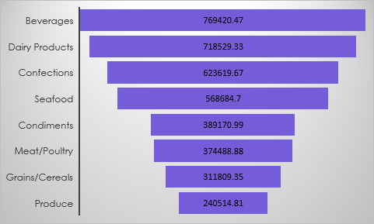

##### Beverages Lead Revenue: Beverages generate the highest revenue, emphasizing their significance within Northwind Traders product lineup.

##### Competitive Dairy and Confections: Dairy Products and Confections closely follow Beverages in revenue generation, indicating their importance as strong revenue drivers.

##### Promising Categories: Seafood and Condiments contribute notable revenue, presenting opportunities for targeted growth strategies.

##### Untapped Potential: Meat/Poultry and Grains/Cereals show potential for increased focus to drive higher revenue.

##### Exploration Opportunities: The Produce category, while contributing comparatively less revenue, presents untapped market potential that could be harnessed through strategic initiatives.

## Are there any correlations between order size and customer demographics or product categories? Can we explore this visually using scatter plots or heatmaps?

##### High Demand Categories: Beverages and Dairy Products demonstrate the highest quantities sold, indicating strong and consistent consumer demand.

##### Significant Interest: Confections and Seafood also show substantial quantities sold, reflecting consistent market appeal and consumer interest.

##### Stable Demand: Condiments and Grains/Cereals maintain stable demand, indicating consistent market interest in these categories.

##### Promising Potential: Meat/Poultry and Produce show promising demand, suggesting opportunities for targeted marketing and potential growth.

## How does order frequency vary across different customer segments? Can we visualize this using bar charts or treemaps?

##### High Demand Countries: Austria, Finland, Ireland, Sweden, and Venezuela demonstrate consistently high order frequencies, indicating strong market engagement.

##### Stable Markets: Belgium, Brazil, Canada, Denmark, Germany, Italy, Switzerland, and the USA maintain stable order rates, reflecting reliable customer engagement.

##### Potential Growth: Argentina, France, Mexico, Norway, Poland, Portugal, Spain, and the UK show moderate order frequencies, suggesting opportunities for targeted expansion strategies.

## Are there any correlations between employee satisfaction levels and key performance indicators? Can we explore this visually through scatter plots or line charts?

##### We don’t have adequate data to analyse the correlation between employee satisfaction level and KPI data on employee satisfaction levels, which can be obtained through surveys or feedback mechanisms, and collect relevant KPI data, such as productivity, sales performance, or customer satisfaction ratings.

## How does employee turnover vary across different departments or job roles? Can we visualize this using bar charts or heatmaps?

##### High Turnover: Sales Representative department shows the highest turnover, indicating a need for targeted retention strategies.

##### Moderate Turnover: Inside Sales Coordinator department demonstrates moderate turnover, suggesting the need for initiatives to enhance job satisfaction.

##### Low Turnover: Sales Manager and Vice President, Sales departments exhibit lower turnover, emphasizing the importance of maintaining employee satisfaction and career development opportunities.

## Can we identify any patterns or clusters in employee skill sets or qualifications through visualizations? How can this information be used for talent management?

##### Certainly, despite data limitations, identifying patterns or clusters in employee skill sets or qualifications can be facilitated through various visualization techniques. Some common methods to uncover underlying structures in the data and represent clusters or patterns include:

##### Scatter Plots: Visualize relationships between different skill sets or qualifications and their distribution among employees.

##### Heat maps: Illustrate the prevalence of specific skills within different employee clusters, providing insights into skill distribution.

##### Network Graphs: Represent the interconnectedness of different skills or qualifications, highlighting their relationships and dependencies.

##### Radar Charts: Compare the skill sets or qualifications of employees across various dimensions, aiding in identifying strengths and weaknesses.

##### Tree Maps: Show the hierarchical structure of skill sets and qualifications within the organization, offering a comprehensive view of the skill landscape.

##### Understanding these patterns can significantly benefit talent management in various ways:

##### Skill Gap Identification: Spot skill gaps and develop tailored training programs to address them effectively. Cross-Functional Team Building: Facilitate the formation of cross-functional teams by identifying employees with complementary skill sets.

##### Efficient Recruitment: Streamline the recruitment process by identifying critical skill sets for specific roles within the organization.

##### Career Development Planning: Plan career development paths for employees based on their current skill sets and the skills required for different roles.

##### Strategic Workforce Planning: Make informed decisions about workforce planning, identifying potential candidates for leadership positions and strategic initiatives.

##### Leveraging these insights, organizations can optimize their talent management strategies, ensuring the right skills are in the right positions to drive the accomplishment of business objectives.

## Are there any correlations between product attributes (e.g., size, color, features) and sales performance? Can we explore this visually using scatter plots or heatmaps?

##### Yes, you can explore correlations between product attributes (such as size, color, features) and sales performance using various visualizations, including scatter plots and heatmaps. Here's how you can do it by following steps but we dont have data for product attributes so we cant do it:

##### 1. Scatter Plots:Single Variable Analysis: For each product attribute (e.g., size, color, or features), create a scatter plot with sales performance on one axis and the attribute value on the other. Each data point represents a product.

##### Multiple Variables Analysis: If you want to explore the correlation between two product attributes and sales, you can create a scatter plot with one attribute on the x-axis, the other attribute on the y-axis, and use color or size of the markers to represent sales performance.

##### 2. Heatmaps:Correlation Matrix: If you have multiple product attributes, you can create a correlation matrix heatmap. In this heatmap, each cell represents the correlation coefficient between two attributes. High positive correlation values (close to 1) indicate a strong positive relationship, while high negative correlation values (close to -1) indicate a strong negative relationship.

##### 3. Analysis and Insights:Identify Patterns: Look for patterns in the scatter plots or heatmaps. For example, you might find that specific colors or certain combinations of features are consistently associated with higher sales.

##### Data Segmentation: Segment your data based on different attributes and then create scatter plots or heatmaps for each segment. This can reveal nuanced correlations that are not apparent when analyzing the data as a whole.

##### Statistical Analysis: In addition to visualizations, you can perform statistical tests (like correlation coefficients) to quantify the strength and direction of the relationships between attributes and sales.

##### 4. Actionable Insights:

##### Product Optimization: Identify attributes that positively correlate with higher sales and prioritize products with these attributes in your inventory or marketing efforts.

##### Customer Preferences: Understand customer preferences by analyzing which product attributes are most popular among high-value customers. Tailor marketing strategies accordingly.

##### Inventory Planning: Use insights from correlations to optimize inventory levels. Stock products with attributes that have strong positive correlations with sales.

##### In summary, visualizations such as scatter plots and heatmaps provide intuitive ways to explore correlations between product attributes and sales performance. These visualizations can reveal valuable insights that businesses can leverage for product optimization, marketing strategies, and customer satisfaction efforts.

## How does product demand fluctuate over different seasons or months? Can we visualize this through line charts or area charts?

##### Spring Dominance: Spring records the highest number of product orders, indicating a peak in customer demand during this season.

##### Winter Follows Spring: Winter follows closely behind Spring in the number of product orders, suggesting sustained consumer activity during the colder months.

##### Autumn and Summer Orders: Autumn and Summer demonstrate relatively lower product orders, highlighting potential areas for targeted marketing and promotional strategies to stimulate demand during these seasons.

##### Understanding the seasonal trends in product orders can guide Northwind Traders in optimizing inventory management, marketing campaigns, and product promotions to align with customer preferences and seasonal demand fluctuations.

## Can we identify any outliers or anomalies in product performance or sales using visualizations? How can this information be used for product optimization?

##### Certainly, visualizations help identify outliers in product performance or sales data, enabling businesses to optimize product performance and overall strategies. Key benefits include:

##### Root cause analysis: Identifying reasons behind outliers aids in understanding issues affecting product performance and consumer behavior.

##### Quality improvement: Addressing outliers related to product quality facilitates improvements in the production process, enhancing customer satisfaction.

##### Inventory management: Analysing outliers in sales data enables efficient inventory management, optimizing stock levels for different products.

##### Market segmentation: Recognizing outliers in customer preferences assists in tailoring marketing strategies and product offerings, enhancing overall sales and market share.

##### Pricing strategy adjustment: Identifying outliers in pricing data guides businesses in optimizing pricing strategies, ensuring competitiveness and profitability.

## Are there any correlations between supplier attributes (e.g., location, size, industry) and performance metrics (e.g., on-time delivery, product quality)? Can we explore this visually through scatter plots or heat maps?

##### Efficient Deliveries: The USA, Australia, and Germany demonstrate the highest number of orders delivered on time, indicating efficient delivery systems and processes in these countries.

##### Moderate Performance: The UK, Italy, and France show a moderate number of orders delivered on time, signifying a need for potential improvements in the delivery process to ensure timely deliveries and customer satisfaction.

##### Opportunities for Improvement: Countries such as Canada, Japan, and Norway display a comparatively lower number of orders delivered on time, highlighting areas for potential enhancements in the delivery process to meet customer expectations and improve service quality.

##### Understanding the delivery time performance across different countries allows Northwind Traders to identify areas for improvement in their delivery processes, optimize logistics operations, and enhance customer satisfaction, thereby strengthening their global market presence.

## How does supplier performance vary across different product categories or departments? Can we visualize this using stacked bar charts or grouped column charts?

##### Timely Deliveries: The majority of orders across different categories were delivered on time, reflecting a generally efficient delivery process and adherence to delivery schedules.

##### Occasional Delays: Some orders experienced delays, representing a small portion of the total orders. This suggests the need for continuous monitoring and improvements in the delivery process to minimize delays and maintain high service standards.

##### Consistent Performance: Overall, the data indicates a consistent performance in timely order deliveries, with only a small fraction of orders experiencing delays, showcasing the company's commitment to efficient logistics management and customer satisfaction.

## Can we identify any trends or patterns in supplier costs or pricing structures through visualizations? How can this information be used for procurement optimization?

##### Variability in Shipping Costs: Shipping freight costs vary significantly across different suppliers, ranging from 53.43 to 183.29, indicating potential differences in shipping methods, distances, or product types.

##### Optimization Opportunities: Suppliers with higher freight costs, such as Supplier 18 with an average of 183.29, may benefit from cost optimization strategies and negotiations to streamline shipping expenses and improve overall cost efficiency.

##### Cost-Effective Suppliers: Suppliers with relatively lower average shipping freight costs, such as Suppliers 10, 22, and 25, present opportunities for maintaining cost-effective shipping solutions and fostering long-term partnerships to ensure consistent and affordable logistics service.

##### Analysing these insights can assist Northwind Traders in making informed decisions related to supplier selection, negotiation strategies, and overall cost management to optimize shipping operations and maintain competitive pricing for customers.

##### Top of Form

# **Conclusion:**

In conclusion, the implementation of the Power BI dashboard for the Northwind Traders dataset has proven to be a pivotal tool in our project analysis. Through meticulous examination of customer data, order patterns, employee performance, product trends, supplier relationships, and shipping logistics, we have gained invaluable insights that are instrumental in making strategic decisions.

By harnessing the power of data visualization and analysis, we have equipped Northwind Traders with the ability to optimize their operations comprehensively. This optimization spans across inventory management, order processing, workforce efficiency, product offerings, supplier collaborations, and shipping logistics. These enhancements not only lead to operational efficiency but also directly impact customer satisfaction.

Utilizing the insights derived from the Power BI dashboard, Northwind Traders can now tailor their marketing strategies to specific customer segments, ensuring a more personalized and engaging customer experience. Moreover, the streamlined order processing and inventory management enable the company to meet customer demands promptly and maintain optimal stock levels, thereby enhancing overall customer satisfaction and loyalty.

Employee analysis has provided a platform for recognizing top performers, addressing skill gaps, and fostering a positive work environment. By aligning employee skills with business needs, Northwind Traders can ensure a motivated workforce that contributes significantly to the company’s growth and success.

In the realm of products, the analysis has unveiled hidden trends and customer preferences. Armed with this knowledge, Northwind Traders can focus their efforts on product development, pricing strategies, and marketing campaigns, resulting in a more competitive product portfolio and increased sales.

Furthermore, supplier and shipper analysis has enabled Northwind Traders to negotiate better terms with suppliers and optimize shipping routes, leading to cost savings and more reliable supply chain management. This, in turn, ensures timely deliveries and reduces operational overheads.

In essence, the Power BI dashboard has transformed raw data into actionable insights, empowering Northwind Traders to make data-driven decisions. These decisions, grounded in comprehensive analysis, not only optimize current operations but also provide a roadmap for future growth and success. By leveraging these insights, Northwind Traders is well-positioned to thrive in a competitive market landscape, enhance customer satisfaction, and achieve sustainable business growth.